AppSettings Application Block for Enterprise Library June 2005

Author: Robert Kokuti MCSD .Net
Date: Sept 2005
Send comments/suggestions to: robertkokuti@hotmail.com

This is a simple, generic application block which can be used similarly to the standard
< appSettings > tag in .Net config files.
With this application block, the content of application settings can be managed with the Enterprise Library Configuration tool.

How to install

- Compile the AppSettings Solution with Visual Studio
- Copy the Kokuti.EnterpriseLibrary.AppSettings.Configuration.Desing.dll to the Enterprise Library \bin directory

How to use

- Add the new AppSettings Application Block to the application:

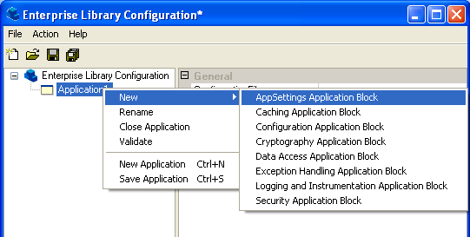

- Add a new Name/Value pair to the Collection:

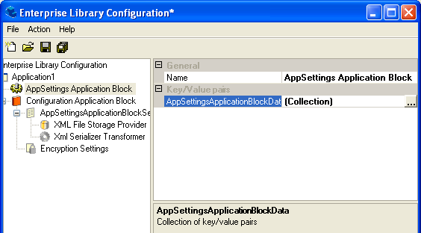

Click on … to get the Collection Editor and add a new Key/Value pair:

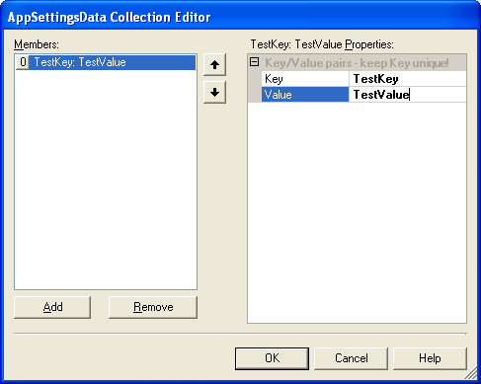

- Access the key/value pair from your app as:

Convenient access to this data is provided through the AppSettingsHelper object: (you have to add a reference to Kokuti.EnterpriseLibrary.AppSettings.dll in your project):

using Kokuti.EnterpriseLibrary.AppSettings;
…
String s = AppSettingsHelper.AppSettings[“TestKey”];

The AppSettingsDemo project shows this and some of the more advanced uses of the AppSettings Application Block, including adding/changing key/values from code, saving the changes and automatically refreshing the app if the configuration changes.

Disclaimer

This Application Block is provided ‘as is’ with no warranties.

